**Assignment 4**

**Name:** Mateo Henao Cardozo

1. Post the link to the repo “RDD”

**Answer:** <https://github.com/mateohenao01/RDD>

1. read Hansen’s paper in the /articles directory of the main class github entitled “Hansen AER”. **Briefly summarize this paper**. What is his research question? What data does he use? What is his research design, or “identification strategy”? What are his conclusions?

**Answer:** In the United States and around the whole world, a big percent of fatal traffic accidents is related with drunk driving, that is why the States have designed punishments determined by strict rules on blood alcohol content (BAC). By using the administrative record on drivers under the influenced blood alcohol content tests in the state of Washington from 1999 to 2011, the researchers estimates with a regression discontinuity design if having a BAC above the DUI (driving under the influenced) threshold reduces recidivism in drunk driving.

This paper offers evidence concerning to the effectiveness of punishment and sanction in recidivism among drunk drivers, they found that having a BAC over the 0.08 legal limit decline the probability in repeat drunk driving over the next four years in 2 percent points, also having a BAC over the 0.15 (aggravated DUI) is associated with an additional 1 percentage point decrease in repeat drunk driving, this reduction in recidivism is explained principally by deterrence.

**Replication**

1. In the United States, an officer can arrest a driver if after giving them a blood alcohol content (BAC) test they learn the driver had a BAC of 0.08 or higher. We will only focus on the 0.08 BAC cutoff. We will be ignoring the 0.15 cutoff for all this analysis. Create a dummy equaling 1 if **bac1**>= 0.08 and 0 otherwise in your do file or R file.
2. The first thing to do in any RDD is look at the raw data and see if there is any evidence for manipulation (“sorting on the running variable”). If people were capable of manipulating their blood alcohol content (bac1), describe the test we would use to check for this. Now evaluate whether you see this in these data? Either recreate Figure 1 using the bac1 variable as your measure of blood alcohol content or use your own density test from software. Do you find evidence for sorting on the running variable?

**Answer:** In order to test if there is manipulation of the blood alcohol content (BAC), McCrary suggest a test where the density should be continuous in the running variable at the cutoff point, if this doesn’t happened there will be evidence to assume that the people is capable of manipulate their BAC. According to the statistic evidence in a conventional method the McCrary test implies a p-value of 0.59 at the cutoff, this result is the same that Hansen (2015) indicates, however, using robust errors to test the manipulation of the running variable, the McCrary test implies a p-value of 0.029 at the 0.08 threshold, therefore there is evidence of sorting on the running variable. Figure 1 contains a histogram displaying the number of observation in each measured BAC level, according to figure 1 there is a jump in the density of BAC levels at the cutoff that supports the results by the McCrary test, also by looking the rddensity plot is observable the discontinuity at the cutoff, although the confidence intervals before and after the threshold intersect in one point

Figure 1. BAC histogram

1. The second thing we need to do is check for covariate balance. Recreate Table 2 Panel A but only white male, age, and accident (acc) as dependent variables. Use your equation 1) for this. Are the covariates balanced at the cutoff? It’s okay if they are not exactly the same as Hansen’s.

**Answer:** According to table 2 there is statistical evidence that the variables male, age, and accident are affected by BAC thresholds, these results suggest that the smoothness of conditional expectation functions is not satisfied and are statistically significant at the 1 percent level. These estimations are different from those that Hansen (2015) estimated.

1. Recreate Figure 2 panel A-D. You can use the -cmogram- command in Stata to do this. Fit both linear and quadratic with confidence intervals. Discuss what you find and compare it with Hansen’s paper.

**Answer:**

* Balance test for Accident at scene

According to the figures for balance test for accident at scene with linear and quadratic as best fit, there is evidence of change in the predetermined characteristic across the punishment threshold. This result is different with the balance figure for accident at scene of Hansen’s paper, when he did not found changes in ACC across the cutoff.

* **Imagen que contiene mapa, texto

  Descripción generada automáticamenteImagen que contiene mapa, texto

  Descripción generada automáticamente**Balance test for Age

According to the figures for balance test for age with linear and quadratic as best fit, there is evidence of change in age across the punishment threshold with a linear as best fit(this result are consistent with the findings in table 2), nevertheless, according with the data, the best fit in the balance test for age is a quadratic regression, by using a quadratic fit for the balance test, there is not evidence for changes in this characteristic across BAC cutoff, this last result is equivalent to Hansen’s paper.

* **Imagen que contiene texto, mapa

  Descripción generada automáticamenteImagen que contiene texto, mapa

  Descripción generada automáticamente**Balance test for Male

According to the figures for balance test for male with linear and quadratic as best fit, there is changes in the mean of male across the threshold with a quadratic as best fit, while with a linear fit there is no evidence of discontinuity in the variable across the punishment cutoff. According with Hansen (2015) there is not evidence of changes in the characteristic variable, although the figure in Hansen (2015) without the confidence intervals show a case of discontinuity across the variable.

* **Imagen que contiene texto, mapa

  Descripción generada automáticamenteImagen que contiene mapa

  Descripción generada automáticamente**Balance test for White

According to the figures for balance test for male with linear and quadratic as best fit, there is not evidence of changes in the characteristics across the punishment threshold. These results are equivalent from those found by Hansen (2015).

1. Estimate equation (1) with recidivism (recid) as the outcome. This corresponds to Table 3 column 1, but since I am missing some of his variables, your sample size will be the entire dataset of 214,558. Nevertheless, replicate Table 3, column 1, Panels A and B. Note that these are local linear regressions and Panel A uses as its bandwidth 0.03 to 0.13. But Panel B has a narrower bandwidth of 0.055 to 0.105. Your table should have three columns and two A and B panels associated with the different bandwidths.:
   1. Column 1: control for the bac1 linearly
   2. Column 2: interact bac1 with cutoff linearly
   3. Column 3: interact bac1 with cutoff linearly and as a quadratic
   4. For all analysis, use heteroskedastic robust standard errors.

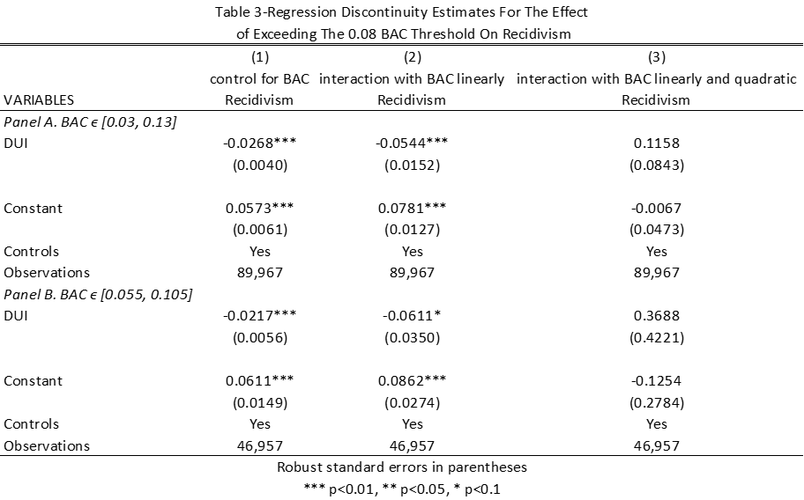**Answer:**

With a bandwidth of 0.05, according with the statistical evidence, having a BAC above the 0.08 threshold decreases recidivism by 2,6 percentage points during a four year follow-up and is statically significant at the 1 percent level (this result is close to the estimation by Hansen (2015)). By interact BAC with the cutoff linearly, having a BAC above the 0.08 decrease recidivism by 5,4 percentage points during a four-year follow-up.

With a bandwidth of 0.025, according with the statistical evidence, having a BAC above the 0.08 threshold decreases recidivism by 2,1 percentage points during a four year follow-up and is statically significant at the 1 percent level (this result is close to the estimation by Hansen (2015)). By interact BAC with the cutoff linearly, having a BAC above the 0.08 decrease recidivism by 6,1 percentage points during a four-year follow-up and is statically significant at the 10 percent level.

1. Recreate the top panel of Figure 3 according to the following rule:
   1. Fit linear fit using only observations with less than 0.15 bac on the bac1

**Answer:**

* 1. Fit quadratic fit using only observations with less than 0.15 bac on the bac1

**Answer:**

